Software Requirements Specification
for
<Project>
Version 1.0 approved
Prepared by <author>
<organization>
<date created>
Table of Contents
Table of Contents ii
Revision History ii
1. Introduction 1
1.1 Purpose 1
1.2 Document Conventions 1
1.3 Intended Audience and Reading Suggestions 1
1.4 Product Scope 1
1.5 References 1
2. Overall Description 2
2.1 Product Perspective 2
2.2 Product Functions 2
2.3 User Classes and Characteristics 2
2.4 Operating Environment 2
2.5 Design and Implementation Constraints 2
2.6 User Documentation 2
2.7 Assumptions and Dependencies 3
3. External Interface Requirements 3
3.1 User Interfaces 3
3.2 Hardware Interfaces 3
3.3 Software Interfaces 3
3.4 Communications Interfaces 3
4. System Features 4
4.1 System Feature 1 4
4.2 System Feature 2 (and so on) 4
5. Other Nonfunctional Requirements 4
5.1 Performance Requirements 4
5.2 Safety Requirements 5
5.3 Security Requirements 5
5.4 Software Quality Attributes 5
5.5 Business Rules 5
6. Other Requirements 5
Appendix A: Glossary 5
Appendix B: Analysis Models 5
Appendix C: To Be Determined List 6

Revision History
Name | Date | Reason For Changes | Version

Introduction

Purpose
<Identify the product whose software requirements are specified in this document, including the revision or release number. Describe the scope of the product that is covered by this SRS, particularly if this SRS describes only part of the system or a single subsystem.>

Document Conventions
<Describe any standards or typographical conventions that were followed when writing this SRS, such as fonts or highlighting that have special significance. For example, state whether priorities for higher-level requirements are assumed to be inherited by detailed requirements, or whether every requirement statement is to have its own priority.>

Intended Audience and Reading Suggestions
<Describe the different types of reader that the document is intended for, such as developers, project managers, marketing staff, users, testers, and documentation writers. Describe what the rest of this SRS contains and how it is organized. Suggest a sequence for reading the document, beginning with the overview sections and proceeding through the sections that are most pertinent to each reader type.>

Product Scope
<Provide a short description of the software being specified and its purpose, including relevant benefits, objectives, and goals. Relate the software to corporate goals or business strategies. If a separate vision and scope document is available, refer to it rather than duplicating its contents here.>

References
<List any other documents or Web addresses to which this SRS refers. These may include user interface style guides, contracts, standards, system requirements specifications, use case documents, or a vision and scope document. Provide enough information so that the reader could access a copy of each reference, including title, author, version number, date, and source or location.>

Overall Description

Product Perspective
The product will be an open source Windows-based application that mirrors the design pattern and functionality of current live stock screeners. It is a Graphical UI application implementing the Model View View-Model. The application provides users the ability to filter stocks based on user-defined specifications.

Main features of the product include:

- Product capabilities: Compatible with Windows 2.7 desktop.

- User account: The application allows the user to create an account and login to view up-to-date stock metrics.

- Filters: Product will have various quantitative constraints a user can implement when searching for stock metrics. Filter info includes price, market cap, and volume.

- Screened Stocks: Application displays stocks based on user-defined metrics. Screened stock information displayed includes stock name, last price, volume, market cap, percent change, and select button for user to elect to watch that stock.

- Watching: Application displays stocks user is currently watching, with stock name and percent change displayed, as well as user ability to remove watched stock.

- Other product features: Application includes ‘save as favorite’ and ‘load favorite’ buttons for users to select to save and view favored filter metrics quickly. Application also includes a secure log out feature when user is finished using the application.

Product Functions
Major functions product must perform include:

- Create a user/login user

- Display stock screener metrics

- Allow user to filter stocks based on user-specific requirements

- Allow user to save filter metrics and reload them using the favorites options

- Display current user watched stocks

- Securely log out user

User Classes and Characteristics
The user is considered to be any individual with the capabilities of operating applications and have a basic understanding of stock information. User has access to account and any changes made by the user are account-specific. Product Administrators have technical support knowledge to maintain and secure the application with full privilege.

Operating Environment
In order for the product to operate, it fundamentally requires a Windows Desktop Environment. Product requires .NET Framework 4.5.1, which comes integrated on Windows 8.1 or Windows 10, and can be installed onto Windows 7. The application works on both 32-bit and 64-bit computer architectures. All computers require strong connection to the Internet.

Design and Implementation Constraints
The product will be completed using tools and techniques as directed by project administrators. Deliverables prescribed are defined in section 3. The following are varying design and implementation constraints:

- In a client-server GUI environment, each user/machine interaction results in some processing at one or more software servers. Therefore, the process of entering a GUI screen and working on a GUI screen will typically result in many system transactions, most of which are transparent and unknown to the user. Each of these transactions requires the user to wait for a response; therefore, each system interaction has a different set of response expectations by the user.
- Due to large quantity of stock data that needs to be updated upon user login, decision keep files with previously known stock values while stocks are refreshed is taken into account.
- It is the responsibility of the project Administrators to submit all aspects of the product at their respective assigned timeframes. All admins are required to adhere to best security and programming standards, and are responsible for the maintenance of the delivered product.

User Documentation
Due to the nature of the product, user is expected to have basic knowledge of stock screeners, therefore, no external documentation is recommended.

Assumptions and Dependencies
For full product functionality, user is expected to have the proper types and versions of Windows software to utilize product interfaces. User is assumed to have good quality Internet connection on their Windows desktop platform.

External Interface Requirements

User Interfaces
The product user interface has been specifically designed with consumer-friendliness in mind, giving them filtered stock metrics in real time. The stock screener UI is designed for easy use, with no need for tutorials or supplemental instruction. The home screen displays the stock screener, showing the stocks and various filter/watch functions that it performs. The user can select stock metrics tailored to their specific needs in the filter section, and then the stock screener is refreshed to display those filtered results. The user can elect to save their filter settings under the ‘favorites’ button, so upon login they can simply apply their favored settings without repeating the filter process. All filter search results pertaining to the queried stocks are displayed. The stocks appear on the screen in a clear and simple format, where the user can then select any stocks they wish to watch.

In the figures below, a mock up of the stock screener product shows the UI from creating a user/login to successfully logging into the account’s stock screener page.
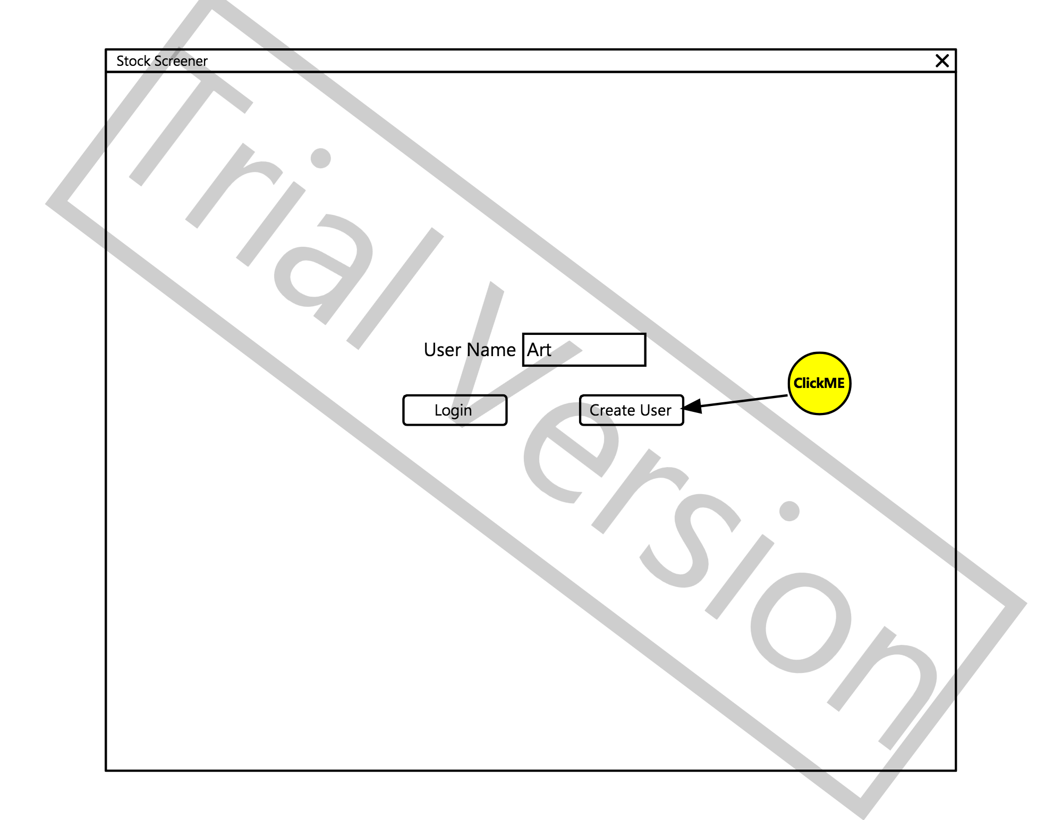

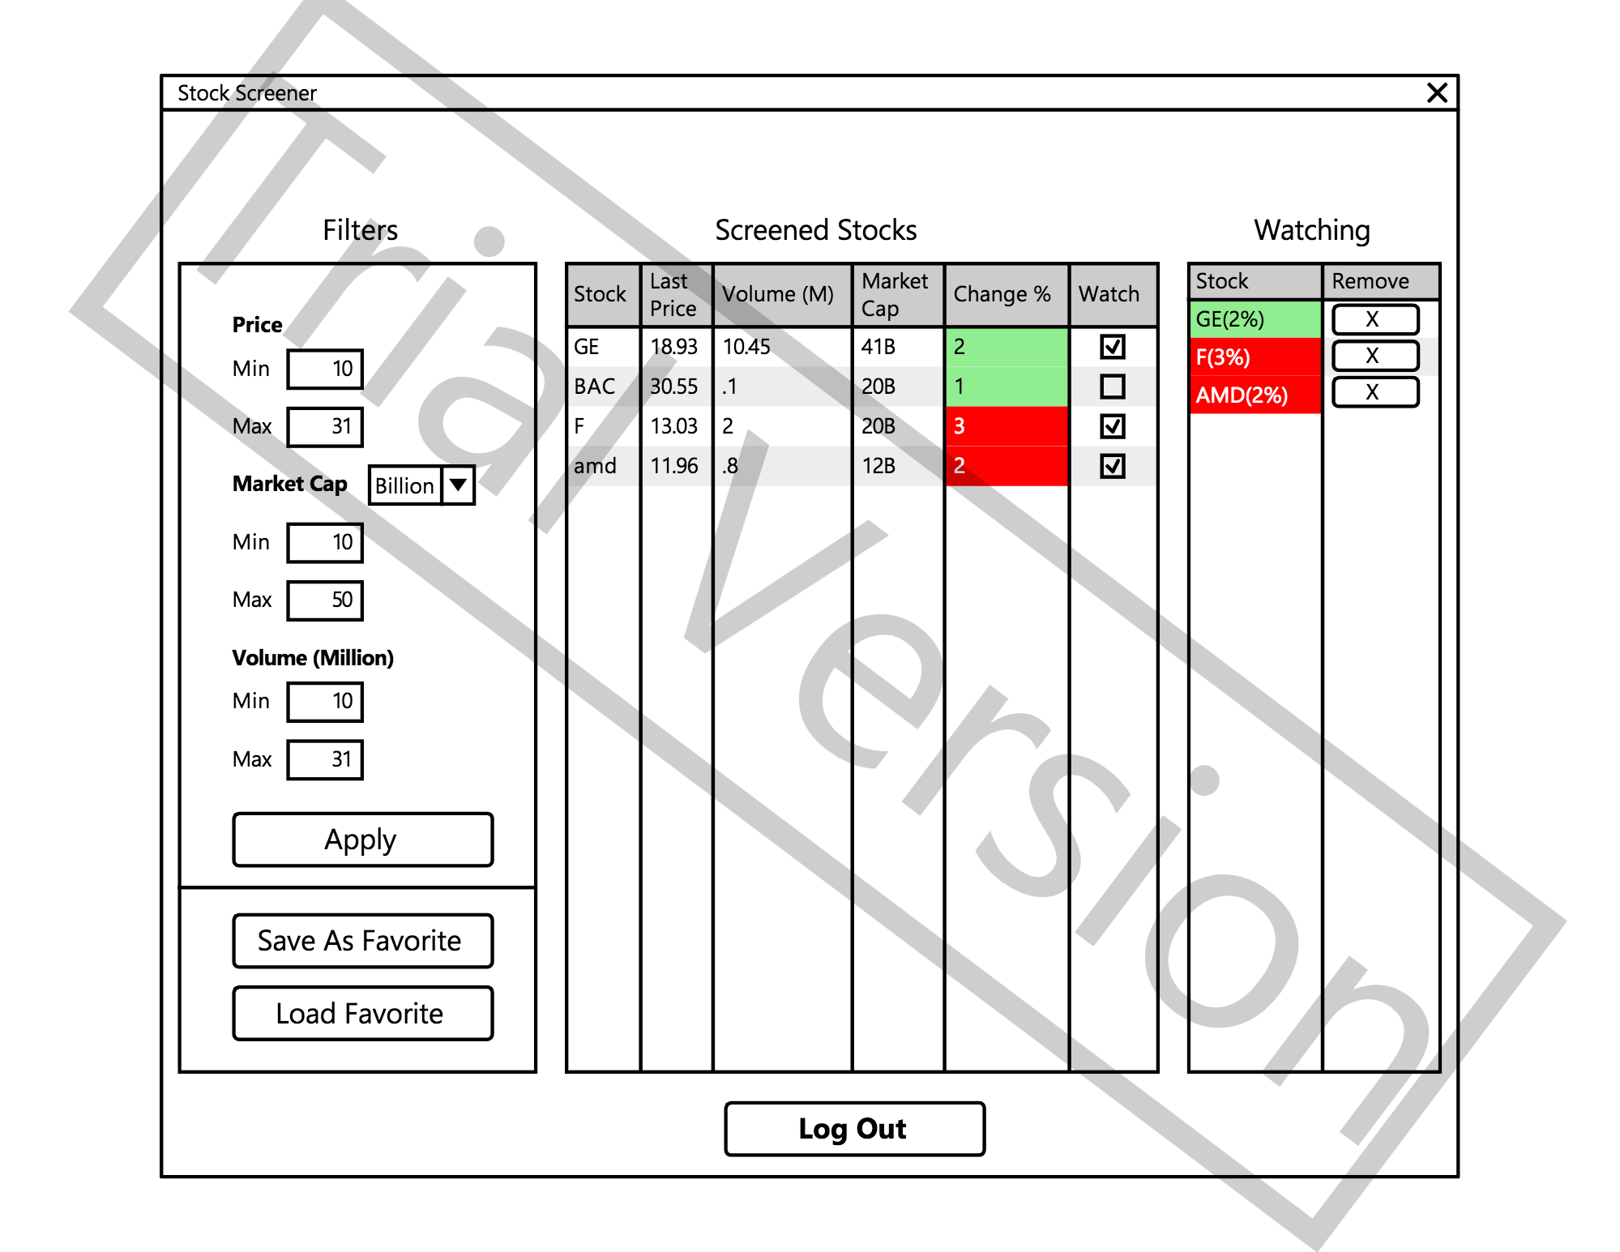

Hardware Interfaces
The following physical and logical hardware components are required for product functionality:

- Standard computer hardware components (power supply unit, motherboard, storage device)

- Input devices (mouse/touchpad, keyboard)

- Output devices (computer monitor)

- Internet connection

Software Interfaces
The following table lists the software used for stock screener product:

Software Used | Description
Operating System | We have chosen Windows OS disk I/O for its support and user-friendly functionality
Developer Platform | To implement the product, we have chosen to use Windows .NET 4.5.1 Framework. This particular framework is open-source, and allows for easy build in CSharp.
Network Capabilities | Our product implements the Windows Networking function, which allows for networking capabilities in the application without making allowances for a particular network provider or physical network implementation.

Communications Interfaces
The product supports HTTP through Windows WebClient API. Product communicates to https://www.alphavantage.co/documentation/ through their API HTTP calls.

